CSCI251 Assignment 3 Program Document

Program Requirements:

The purpose of the program is to read from a text file of Point related coordinates data that is unsorted, un-computed and duplicated records. The program must be able to clean the data of its duplicated and compute either the length of the Line or Distance from Origin of Point from 0, 0. Once cleaned, stored and computed. The program must offer options to sort, display and output into a text file following the assignment document. The types of data that are possible in the text file are Point2D, Point3D, Line2D and Line3D. For displaying and storing the data into a file, the relevant headers must be related to the data type it is displaying.

Program Design:

My program stores the 4 types of data(class) instances in 4 separate vectors. Additionally, it also stores the original strings read in from the file and the cleaned (duplicate free) strings from the stored file.

As for the 4 classes, each class will have its appropriate operators overloaded and additional static methods for using <algorithim>’s sort to the correct output.
The classes are implemented in the same way as recommended by the assignment document (Appendix B) as shown below.

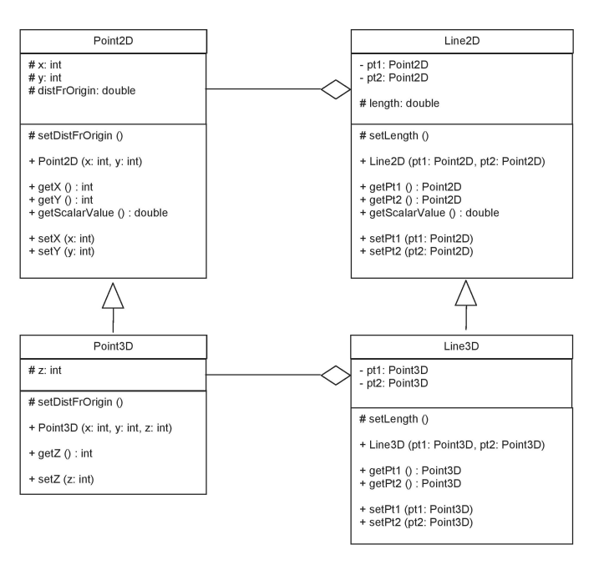

For the filter, sorting and order modes, the names are stored in a list as shown below for simple menu printing and index based reference during runtime for which dataset and which order should the output be displayed in. An integer for each mode is also stored and assigned accordingly during runtime for clearer implementation.
Here is a snipped of the lists and the data stored:
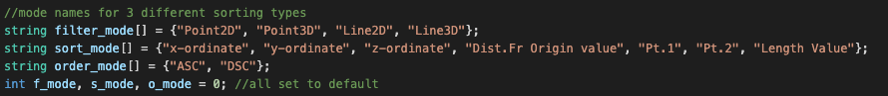

With this backbone, the program revolves around switch statements as each modes index will be used to determine which data and what order should it be displayed in.

Summary on each program module:

Point2D.h and Point2D.cpp

A parent class to Point3D which will be elaborated later. It stores 3 attributes, int X, int Y and double DistFrOrigin which is computed during construction run time. It calculated the distance from point 0, 0 during run time by using the formula as given in the assignment document:
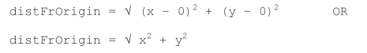

Additional operator overloading was implemented for “greater than” , “lesser than” and “equals” symbols which is used for sorting by distance from origin and “equals” template function that is stored in “MyTemplates.h”.

Static Boolean methods were also created to aid in the sorting of data in terms of its X , Y values in both ascending and descending order. Additional condition statements were added as an additional feature in the program so that sorting by X or Y values will have a “sorting and bunching” effect when the X or Y values are equal, it will take the opposing X or Y value as precedence instead.

Point3D.h and Point3D.cpp

A child class of Point2D, it inherits the X and Y values and stores and additional Z value, it also inherits the DistFrOrigin variable but its function for calculating its value is different from Point2D and instead uses this formula as shown below:

Squareroot(x2 + y2 + z2)

As for the operators that are overloaded, the same symbols are overloaded and implemented similarly as they only “interact” with the same DistFrOrigin value.

For Static Boolean methods, they are implemented exactly the same as in Point2D but with an additional method for comparing int Z in both ascending and descending order. Additional comparison statements were added to take into account if X and Y are equal, the next value that should take precedence will be Z.

Line2D.h and Line2D.cpp
A parent class to Line3D, it stores 2 Point2D object and a double “length” variable. 2 types of constructors are made, 1 where if Line2D is initialised by 4 integers as parameters and the second one where Line2D is initialised by 2 Point2D objects.

The length of the line is calculated using this formula as shown in the assignment document:

Operator overloading was implemented for the “greater than” , “lesser than” and “equals” symbols where the “length” of the object is being used for comparison to aid the sorting.

For the static Boolean method of this program, comparing of point 1 and point 2, it uses the static comparison methods found Point2D to compare each points precedence in ascending and descending order, as the additional feature of having Y come into comparison if the X values are equal, these functions are also able to have the same feature implemented during the sorting function.

Line3D.h and Line3D.cpp
A child class of Line2D, it stores 2 Point3D objects and inherits the length variable from Line2D. It also have 2 constructors were it is either initialised by 6 integer values as parameters or 2 Point3D objects as parameters.

The length of the line also uses a different formula as shown below:

Operator overloading was implemented for the “greater than” , “lesser than” and “equals” symbols where the “length” of the object is being used for comparison to aid the sorting but as the “right hand side” parameter will be a Line3D object, the method has to be copied over and changed to suit its use case.

As for the static Boolean method of this program, comparing of point 1 and point 2, it uses the static comparison methods found Point3D to compare each points precedence in ascending and descending order, this is a variance of the static functions found in Line2D, but since Line3D consists of 2 Point3D objects, it has to be re-written to suit its implementation case. Additionally, since in Point3D already has the additional conditional statements to check if X values and Y values are equal, the sorting precedence will then take into account for the Z values.

Csci251.cpp
The main function of the program, it has 3 menu functions for the main menu, filter menu, sorting menu and order menu. For reading a text file, the function readFile() was implemented, its reads in a file line by line in the same root directory and stores them in a vector called “all_Records”. Upon completion, it then stores the unique values into another vector called “unique_Records”, its algorithm uses a simple if-else config and iterates through the whole unique_Records vector to check for a match, if a match is not found, then append the new value into the vector. Once all the unique values have been stored, a function called pre_Processing() will run which will take all the string values in unique_Records vector, removes the [ and ] brackets, delimits them with “, ” and initialise the class objects into its appropriate vectors using string matching of the first string instance before the “, “. It will then initialize and push back each object with its parameters from the tokenised string values found in unique_records appropriately.

For the next key function viewData(), it will use nested switch statements referencing integers f_mode and s_mode to determine which sorting comparator function to use on which data type. f_mode and s_mode are assigned based on the inputs given by the user for all the menu functions , changeFiltering(), changeSorting() and changeOrder(). Upon the appropriate switch cases of f_mode and s_mode, it will output the correct data output whilst calling the appropriate static methods of each data type. As the insertion “<<” operator is overloaded for all classes, the appropriate output will be displayed simply with a few lines as shown below:

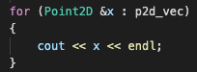 Point2D as an example.

For the final key function storeData(), it uses the same framework as viewData but instead of using “cout” it will using the fstream to store them into the user defined file name.
Point2D as an example.

MyTemplates.h

2 function templates were implemented, scalar_difference and equals. scalar_difference will return the absolute difference between 2 objects by simply calling the .getScalarValue() function which was implemented in all 4 classes. As for equals function, it will return true if both objects are equal “==”, as the 4 classes have the equals symbol overloaded, the correct defined behaviour will occur for all data types.

Reflections:

This program was a good exhibit on operator overloading and static functions and how to use them as parameters in sort() from the algorithms library. Things I could have done better would be to create functions for displaying/storing each data type report as my nested switch statement approach has a lot of duplicate lines of code and implementing them as functions would have greatly saved myself implementation time when it comes to writing them out in my program. But due to the tight deadline schedule, it would be risky to overhaul its current logic to implement and re-test the new function approach.

The only challenge I faced was during my testing, the data file that I created for testing had a missing “,” in one of the rows of data, this caused my program to seg fault consistently and brought me on a wild goose chase in debugging and finding the error in my code. I spent 3 days researching the possible causes, tried storing the values in a vector of pointers, implemented copy constructors, destructors, move constructors and even switching .push_back() from the vectors library to .emplace_back hoping it would stop my programming for seg faulting. The last place I expected to have an issue was my test text file. Upon finding the root cause of this bug was a typo I made to the test file, it was a huge sense of relief and a massive slap to the face as upon cleaning up the file, my program worked as intended. This made me realise that sometime in life, solutions are usually found in the place you least except.

Things I have learned from this assignment was how to operator overload appropriately , more OOP experience and knowledge and a more in-depth familiarity with vectors which will come in very hand in my future career as an aspiring software engineer.

